  - Network Topologies
  - Key Revision Facts: GCSE Computer Science

There are different ways of setting up a LAN, each with different benefits in terms of network speed and cost. Three of the main topologies include bus, star and ring.

Bus network
In a bus network all the workstations, servers and printers are joined to one cable - 'the bus'. At each end of the cable a terminator is fitted to stop signals reflecting back down the bus.
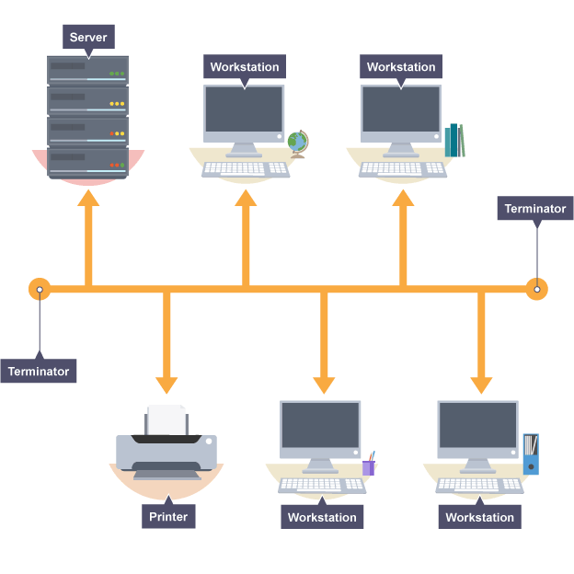

- Advantages
  - easy to install
  - cheap to install - it does not require much cabling
- Disadvantages
  - if the main cable fails or gets damaged, the whole network will fail
  - as more workstations are connected, the performance of the network will become slower because of data collisions
  - every workstation on the network 'sees' all of the data on the network, which can be a security risk

Ring network
In a ring network, each device (eg workstation, server, printer) is connected in a ring so each one is connected to two other devices. Each data packet on the network travels in one direction. Each device receives each packet in turn until the destination device receives it.
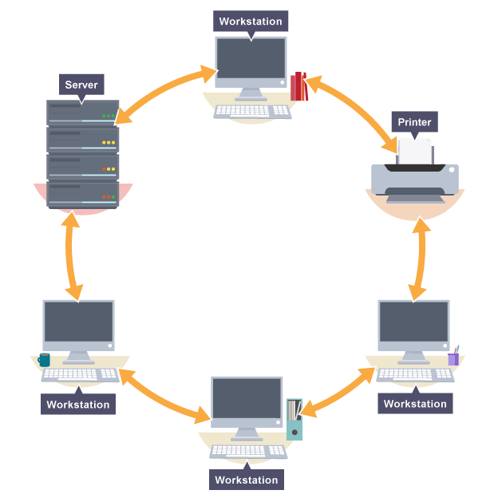

- Advantages
  - this type of network can transfer data quickly (even if there are a large number of devices connected) as data only flows in one direction so there won't be any data collisions
- Disadvantages
  - if the main cable fails or any device is faulty, then the whole network will fail - a serious problem in a company where communication is vital

Star network
In a star network, each device on the network has its own cable that connects to a switch or hub. This is the most popular way of setting up a LAN. You may find a star network in a small network of five or six computers where speed is a priority.

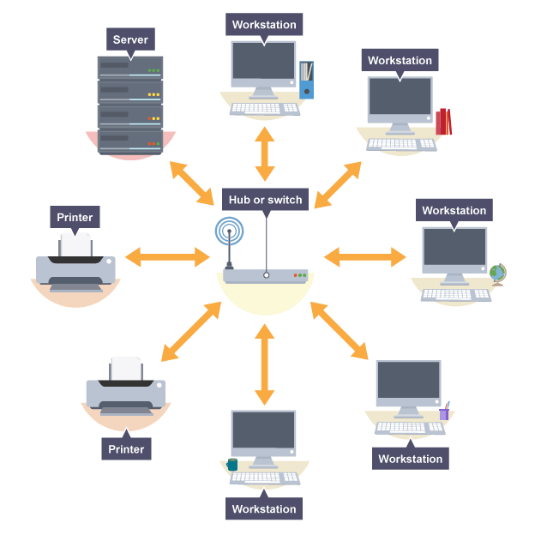
- Advantages
  - very reliable – if one cable or device fails, then all the others will continue to work
  - high performing as no data collisions can occur
- Disadvantages
  - expensive to install as this type of network uses the most cable, and network cable is expensive
  - extra hardware is required - hubs or switches - which add to the cost
  - if a hub or switch fails, all the devices connected to it will have no network connection

